LIVE CLOCK

To create a live clock using Html, Css & Javascript.

Clock Design :

To insert the given png in html tag. and create the clock class.

clock design1.JPG

Then using the class name create a css function to create a clock design based on the pc pixels.

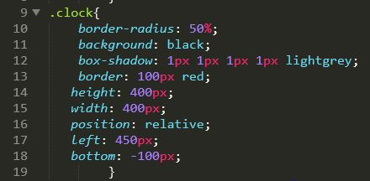

Output:

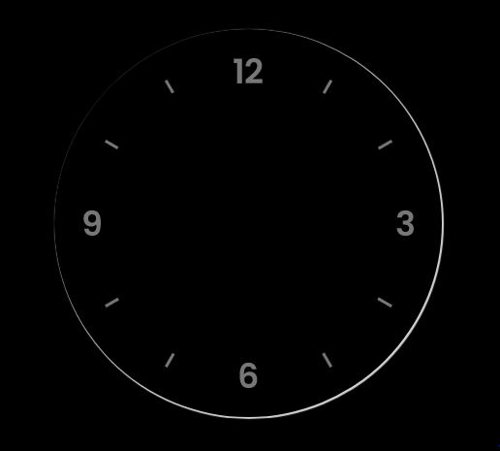

To create a centre point for the clock

center dot1.JPG

Create a dot class in body.

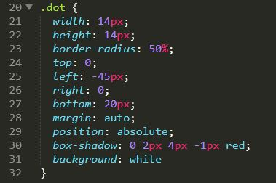

Using the class create a css function to make a centre point of the clock

dot.JPG

To create a clock hand . we need three hand to show hours, minutes, seconds.

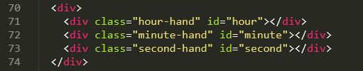

Create a three class to create a clock hand mention by ID to write script function.

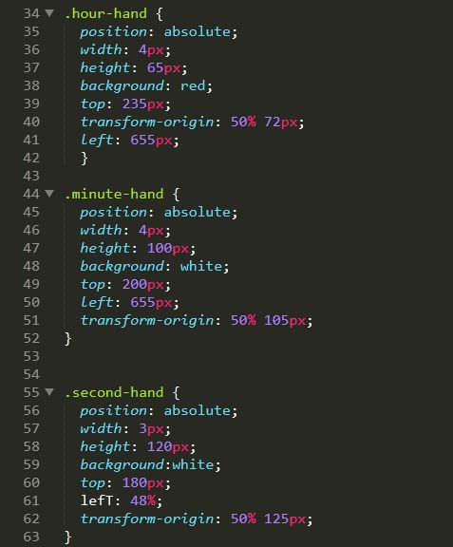

Output:

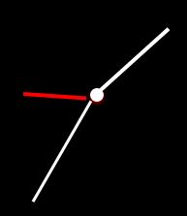

Finally we created a clock structure using html & Css.

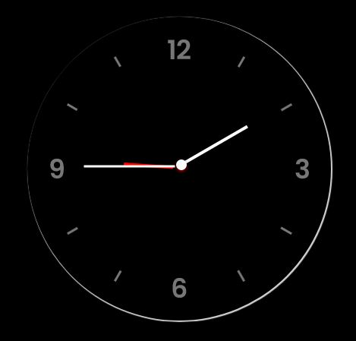

**Running Clock Idea:**

for(i=1;i<24;i++)

{

for(j=0;j<60;j++)

{

1(hour) 1(min) 0(second)

for(k=0;k<60;k++)

{

1(hour) 1(min) 60(second)

//change seconds

}

//Change minute

}

if(i==13)

{

i=1;

}

// change hour.

}

I=hours

J=min

K=second

Hour will start with 1. When the loop is executed it will move to min den again seconds . we should increase the seconds by count and increase a min count to the condition .same the hours.

In seconds the count cross the condition the mini will executed we will get the clock cycle.

To rotate the clock hand we can use **STYLE TRANSFORM PROPERTY. In javascript**

Reference link : <https://www.w3schools.com/jsref/prop_style_transform.asp>

First Try:

To rotate the object using the degree

EX:

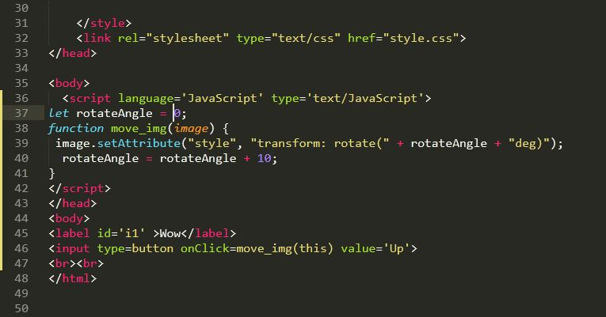

I have created a sample program to rotate the give button in click using the angles 0deg and adding with 10 deg to rotate the button. And it is executed and got result.

Output:

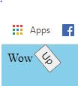

Second Try:

While clicking the button the function executed . next searched the function using the setInterval(). To execute the function to run.

Reference Link: <https://www.w3schools.com/js/js_timing.asp>

**Rotate angle counts:**

15*6=90-> min

15*6=90->sec

12*30=360->hour

72*5=360->hour moment

hour =9

hourdeg=9*30=270

min =45

mindeg=45*6=270

Sec =45

secdeg=45*6=270

hourdeg(should not be in 270 should change near(290deg) 10hrs)

hourDeg+=(minuteDeg/72)*6;

hourdeg=270+(270/72)*6

=270+3.8 ->(4)*6=270+24 =294.

Condition:

In condition the seconds is increasing the values. 0 to 60 after change to seconds to 0 and increase the 1 to minute. After the minute croess 60 hange ount to 0 and increase 1 in hours. After reaching hour to 13 make to 1 for 12 hrs calculation.

Javascript:

To construct a run clock based on system time.

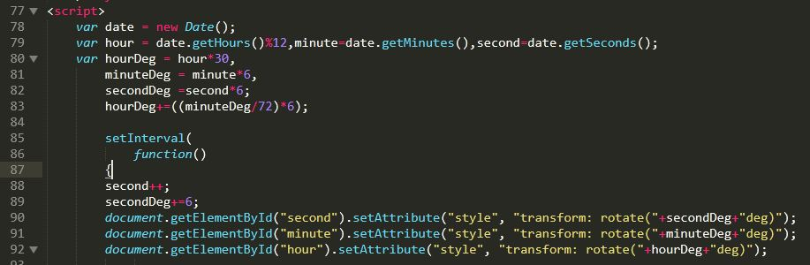

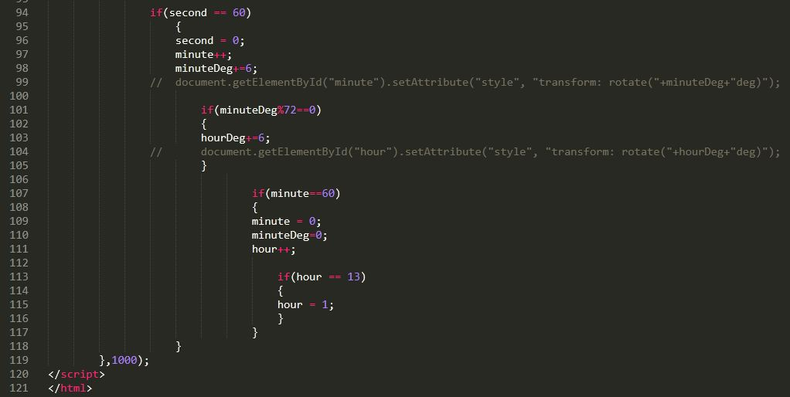

Output:

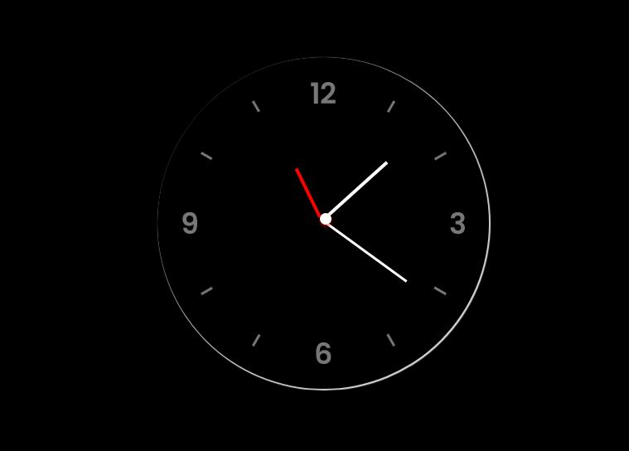

Reference Link: <https://www.w3schools.com/js/js_timing.asp>

Reference link : <https://www.w3schools.com/jsref/prop_style_transform.asp>